**SPECIALIST SEXUAL VIOLENCE AND ABUSE PATHWAY SOUTHEND, ESSEX & THURROCK (SET)**

This pathway is for urgent and non-urgent process. It is provided for managers and all staff, who should familiarise themselves with the pathway and who to notify.

Please also see the Specialist Sexual Violence and Abuse Infographic provide with this document. The infographic should be printed and displayed.

The following can never be resolved internally and should always be reported to the Police, regardless of victim / family views:

 Unexpected Incidents of Death or where actions of another may have led to the death,  All Sexual Offences (regardless of severity) & Assaults

Any ongoing incident that presents a threat to life and/or serious injury, call Police on 999



**IN ADDITION TO THE POLICE, ALL SEXUAL INCIDENTS REGARDLESS OF SEVERITY, SHOULD BE REFERRED ADULT SOCIAL CARE WHERE THE ADULT HAS CARE AND SUPPORT NEEDS.**

**Adult Social Care telephone numbers:**

|  |  |
| --- | --- |
| Southend | 01702 215008 |
| Essex | 03456 037630 |
| Thurrock | 01375 511000 |

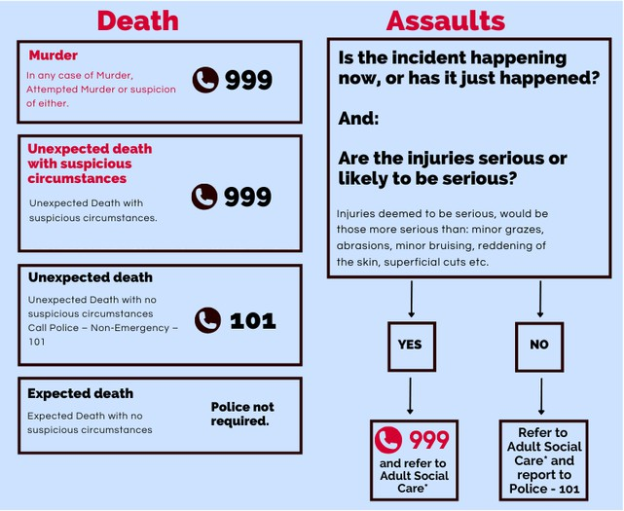

Original version of this flow chart was kindly provided by Norfolk SAB.

**Requirements, Knowledge, and Training**

Ensure you have established a first disclosure process which includes do’s and don’ts Complete sexual violence and abuse eLearning (from ICENA).

Information on the Sexual Offences Act 2003 (SOA 2003) introduced several new offences, for example, offences committed by care workers. The offences against those with a mental disorder are split into three categories. These are:

 offences against a person with a mental disorder impeding choice. This covers individuals whose mental functioning is so impaired at the time of the sexual activity that they are unable to refuse.

 offences against those who have the capacity to consent to sexual activity but have a mental disorder which makes them vulnerable to inducement, threat or deception.

 offences by care workers against those with a mental disorder.

**Support for Victims, Survivors and Professionals**

Synergy Essex offers a first contact through telephone support to victims, survivors, and professionals across Essex. Please call 0300 003 7777 to talk to one of an Essex-wide team of First Contact Navigators.

The team are all specially trained and will guide callers to the services they need in their local area, helping them to access the right support, at the right time. There is an online referral form for self and professionals here [https://synergy essex.org.uk/](https://synergyessex.org.uk/)

**Does the adult have capacity to consent to a referral to police and or SARC?**

If the adult has capacity and does not consent to a referral and there are no public or vital interest considerations*, they should be given information about where to get help should they change their mind or if the abuse or neglect continues and they subsequently want support to promote their safety.

The referrer must assure themselves that the decision to withhold consent is not made under undue influence, coercion or intimidation. The adult will need to be informed that a concern will still need to be raised and as a minimum a record must be made of the concern, as well as the adult’s decisions with reasons. A record should also be made of what information the person at risk was given.

*Public or Vital Interests include situations where:

 There is a high risk to the health and safety of the adult.

 Other people or children could be at risk from the person causing harm.  It is necessary to prevent crime.

If there are concerns that the person may lack capacity to consent to the referral and or support, then a proportionate mental capacity assessment must be carried out to determine whether this is the case. This can be carried out anyone with the necessary skills to do so. If the person lacks capacity to consent following the mental capacity assessment, then a Best Interest Decision must be made to confirm that accessing the referral will be in their Best Interests.