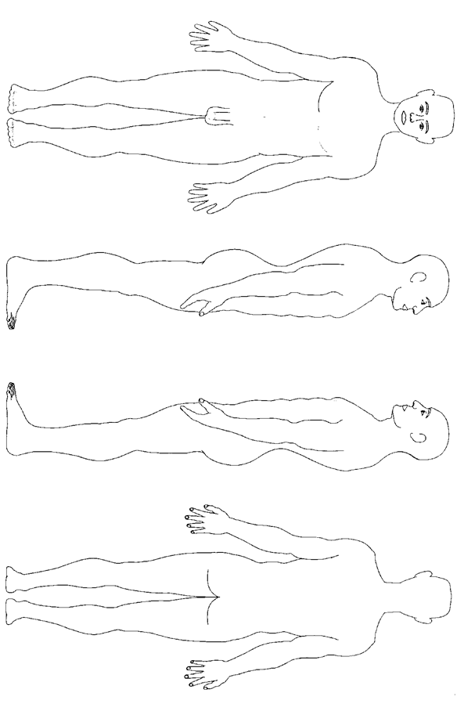

**Body Chart Male**

Please describe any marks you make on the chart e.g. cut, bite, bruise (and whether yellow or blue etc.)

Completed by: Date and time:

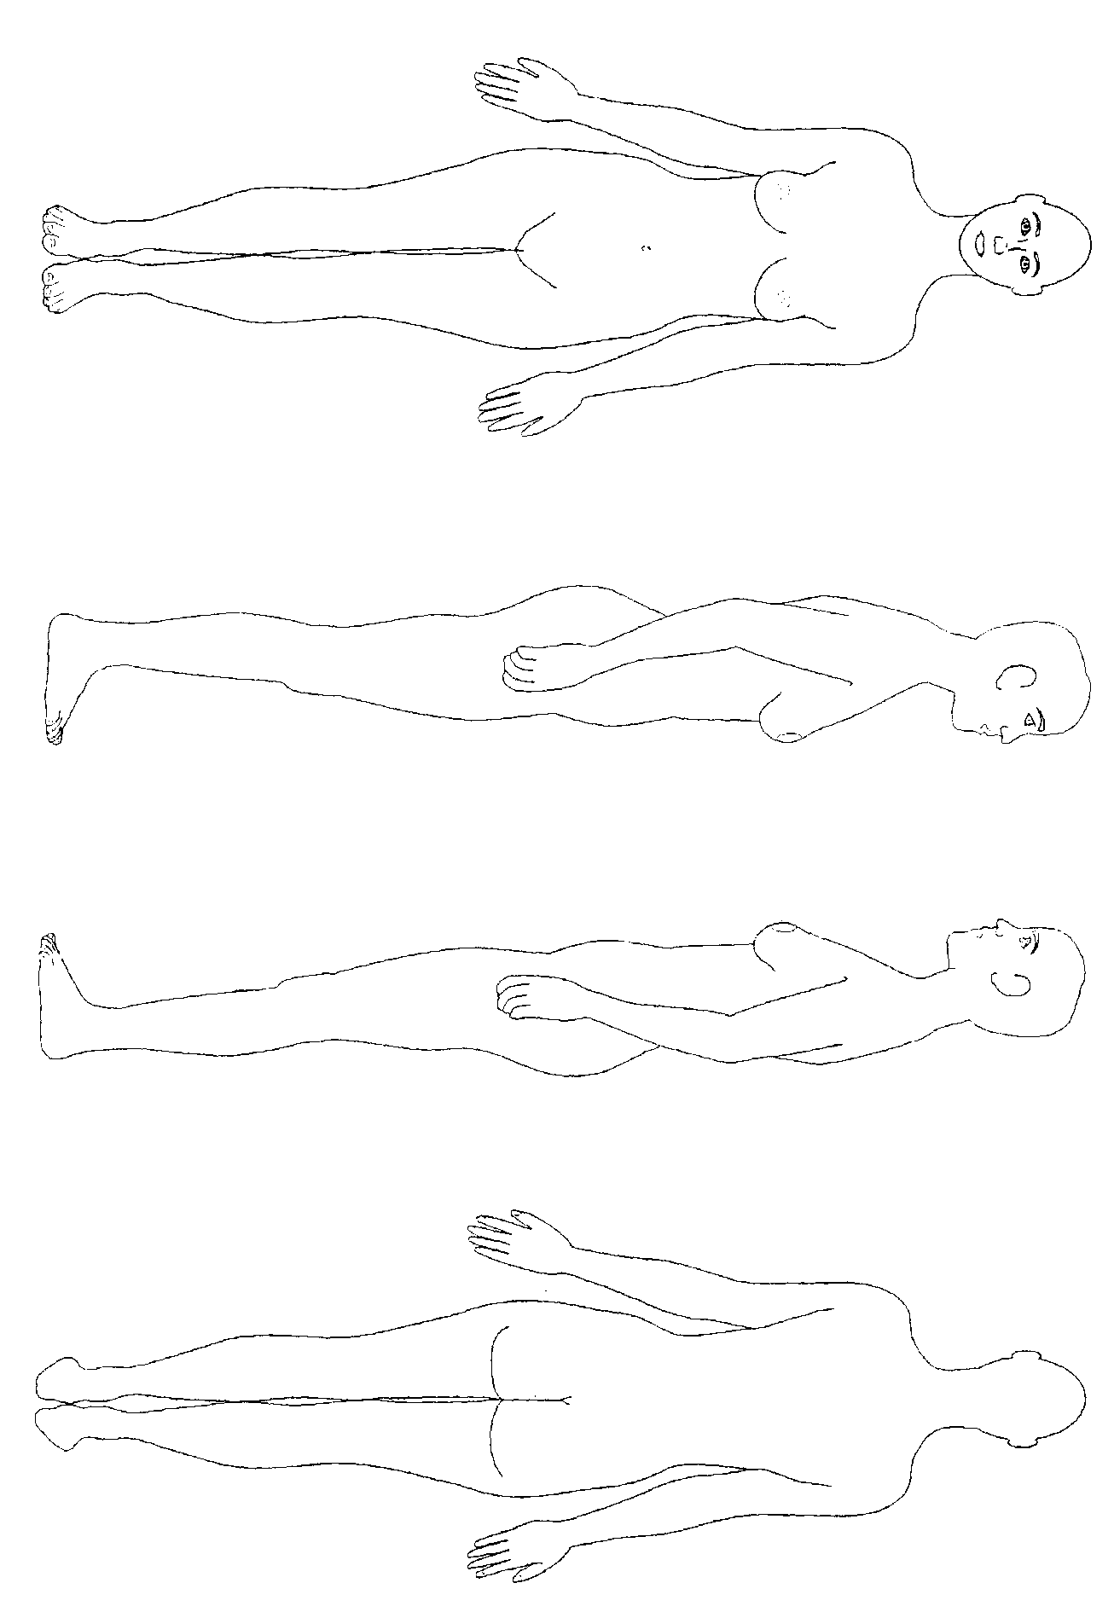

Please describe any marks you make on the chart e.g. cut, bite, bruise (and whether yellow or blue etc.)

Completed by: Date and time:

**Body Chart - Female**